Software Testing Concurrency Bug Analysis

Notify() Instead Of NotifyAll() Bug

Prepared for :

Dr. Shmuel Ur

Prepared by :

Tomer Sharon Id: 038555819
Ofir Germansky Id: 031594427

Software testing course
Department of computer science

Table of Contents

1. The Application 3
1.1. Application Overview 3
1.2. Application description 3
1.2.1 Types and Constants 3
1.2.2. Application Logic 3
1.3. The Bug 4
1.3.1. The Bug Description 4
1.3.2. A Basic Example of The Bug 5
1.4. Application Parameters 5
2. RaceFinder tests & Results 6
2.1. Overview 6
2.2. Test Descriptions & Results 7
2.2.1. Introduction to the program testing 7
2.2.2. Basic test 7
2.2.3. Yield test 7
2.2.4. Barrier test 8
2.2.5. Multiple noise sources test 8
2.3. Results Analysis 9
2.4. Conclusions 9
3. Finding The Bug 11
3.1. Overview 11
3.2. Algorithm For Causing The Bug To Appear 11
3.2.1. Brief Description of The Algorithm 11
3.2.2. The Algorithm 11
3.2.3. A Note 12
3.2.4. Conclusion 12
4. Summary 12

1. The Application

1.1. Application Overview
The application goal is to manage a single buffer, while a number of producers and consumers are trying to access it in order to either insert an Object or extract if from the buffer.

1.2. Application description

1.2.1 Types and Constants
The Buffer object is of the type Object[] and is accessed only through two synchronized methods of the same lock object (the class Buffer): Enq() for insertion and Deq() for extraction.
Two types access the buffer: the first is the Producer, while the second is the Consumer.
The number of both of them is identical and equal to Nt, which is the number of Instances created from one of the types. Each Instance is an Object of class Thread(). Thus, the total number of threads in the application is 2Nt.
We will name each Instance of type Producer as P and each Instance of type Consumer as C.
The task of the Producer is to try to insert a new Object into the Buffer, while the task of the Consumer is to extract one Object from the Buffer. Both insertion and extraction are done at the head of the Buffer. The Buffer size will be related to in the future as N.
Each one of the instances created from either type can access the buffer only for a constant number of times, which is equal to Na. After one instance reaches the limit Na its role in the program ends.
In conclusion the total number of accesses made by either Producers or Consumers is : Nt * Na.

1.2.2. Application Logic
The Access to the buffer can be given to only one Instance (Thread) at a time, because the two methods: Enq() and Deq() have the same synchronized object – Buffer class. So the lock may be given to access only one method by only one Instance.
Each Instance can be either active or inactive, which means that the Instance had reached it's access limit to the buffer.
Each active Instance can be at one of two states: ready or suspended, which means that while remaining in the suspended state it can’t access the buffer.
All active Instances at ready state may access the Buffer. The Synchronizer will pick only one.
When the Buffer lock is free the Synchronizer will immediately look for an active Instance at the state of ready. If more than one exists then it will choose only one and let It access Enq() or Deq().
The first thing which is done is either Enq() or Deq() is checking the status of the Buffer, using the Buffer Access Logic:
- In method Enq(), if the Buffer is full, P can’t access the buffer and consequently its state will change to suspended.
- In method Deq(), if the Buffer is Empty, C can’t access the buffer, consequently its state will change to suspended.
- If none of those conditions occurred, P or C may continue accessing the buffer successfully.
If one of those conditions occurred, the Producer or Consumer give up the lock, so other Instance may access the Buffer afterwards the Instance will change its state to be suspended by the wait() command.
After one Instance has successfully accessed the Buffer, it reaches the end of either Enq() or Deq() methods and then it will run the notify() command, causing one of the active Instances at the suspended state to change its state to be ready again. Meaning that one Thread who was in a loop by the wait() command will wake up by the notify() command invoked by a different Thread who had just finished accessing the Buffer.

1.3. The Bug

1.3.1. The Bug Description
The bug in the program starts when part of the Instances are waiting (suspended) and one Instance who had just finished accessing the Buffer, has woken up the wrong kind of type, Such as a Producer while the Buffer is full or a Consumer while the Buffer is empty. Thus, causing the woken Instance to change its state once again to be suspended.
The bug occurs when all the active Instances are in a suspended state. Therefore, no available active Instance at ready state exists to access the Buffer, and if successfully so, wake up one of the suspended Instances so it in its turn will wake up the next and so on.
The bug would not have happened if we had used NotifyAll() instead of the Notify() command we used. NotifyAll() would have woken all the Instances. Because the number of inserting Objects is equal to the number of extracting them, when using NotifyAll(), it guarantees us that the program would never get stuck in a deadlock.
When the bug occurs the program gets stuck in a deadlock. The program senses the deadlock when for a constant amount of time there hasn’t been any attempt to access the Buffer. Then, the Program ends and a bug notification is received.
The message describing the bug includes the amount of Instances (Threads) stuck in a loop from the total of Instances created at the beginning of the program.
As the program goes on, the number of Instances that become inactive rise. So we can conclude that a bug notification, saying that, for example, 48 from 48 of the Threads got stuck in infinite loop tells us that the bug occurs early. If , for example, 24 from 48 of the Threads got stuck in infinite loop then the bug, occured late in the program running.

1.3.2. A Basic Example of The Bug
For a basic demonstration of the bug, we will show a sequence of steps, showing the state of access to the Buffer (either successful or unsuccessful attempts). The table below shows the state of each Instance in the program and the buffer state. In each step the Synchronizer chooses the Instance, which will access the Buffer (in bold).
An Instance that was woken by another Thread will be marked in an italic style.
The number of Producers / Consumers is two. The Buffer size is 1, meaning the Buffer can be either empty or full.
- Step 1 is the initial state.
- The result to the buffer is implied to the buffer at the same step. For example, in step 2, one Producer is marked in bold and in Ready state, which means that it was trying to access the Buffer. Remaining in Ready state means that the access was successful and the result is the full Buffer, in the same step row.

Buffer | C | C | P | P | step
0 (empty) | Ready | Ready | Ready | Ready | 1
1 (full) | Ready | Ready | Ready | Ready | 2
1 | Ready | Ready | Suspended | Ready | 3
1 | Ready | Ready | Suspended | Suspended | 4
0 | Ready | Ready | Ready | Suspended | 5
0 | Suspended | Ready | Ready | Suspended | 6
0 | Suspended | Suspended | Ready | Suspended | 7
1 | Suspended | Suspended | Ready | Ready | 8
1 | Suspended | Suspended | Suspended | Ready | 9
1 | Suspended | Suspended | Suspended | Suspended | 10

As seen at this example, all the Instances got into suspended state, thus stuck in infinite loop.
Thus, causing the bug. If we had used NotifyAll() in step 5, the consumer would have woke the two Producers and when one Producer, in step 8, would access the Buffer, it will end up wakening the rest of the Instances including the Consumers, and so on, never letting all the Instances in suspended state.

1.4. Application Parameters
- The size of the Buffer is 3. It needs to be as small as possible In order to let the Buffer be full or empty as rapid as it can be.
- The time each Instance is allowed to access the Buffer is 10 times for a Producer and 20 times for a Consumer Instance.
- The number of Producer / Consumer is changed by the concurrency parameter:
  - Little: Nt = 2 Threads
  - Average: Nt = 16 Threads
  - High: Nt = 32 Threads
- After 3 seconds of no reaction from any Instance the program receives a timeout, concluding that all the active Threads are stuck in an infinite loop.

2. RaceFinder tests & Results

2.1. Overview
As mentioned earlier, the program lets only one Thread run at a time, this is because the access to the Buffer is mutualiy excluded. Thus, it can be safe to assume that using a noise of any kind to the program will only suspend its operation, but no more than that.
If we will use noise on a running Thread, who is now accessing the Buffer, the program will not be able to continue running, because the lock for accessing the Buffer is held by the Thread we try to halt. Which means that unless we find a way to release the lock of the Thread before applying the noise, this course of action will never force the bug to happen.
Returning from one of the methods (Enq() or Deq()) is the only way we will be able to regain the lock, but doing so before the insertion/extraction of the Object will damage the course of the program, and introduce us to a different bug. That is, because the number of Objects we insert is equal to the number of Objects we extract. Returning from the method without inserting/extracting an Object will make an uneven situation, which can cause the Buffer to be ever full or ever empty.
Returning from the methods (Enq() or Deq()) after the action is meaningless because, anyway after the action had been taken the method has finished its job.
In both cases we need to remember to run the Notify() command which we was skipped by returning too early from the method. Failing to do so will either, introduce us to another unwanted bug.
Another way of causing the bug to appear, is by using the Yield() command, which is supposed to give up the running time of one Thread for the sake of another. But using Yield() will only suspend the programs as well as any noise. Because of the fact that the Thread we are applying Yield() on is holding the lock, no other Thread can run. And so, by using Yield() the current Thread, will give up its running time momentarily, which will be given to the main Thread, which is the only Thread running, accept for the current Thread. Thus, causing only a mild suspension in the course of the program.
Nevertheless we will try using RaceFinder with various noises and with different concurrency parameters, so we will be able to confirm our assumptions.

2.2. Test Descriptions & Results

2.2.1. Introduction to the program testing
In order to test our program we will introduce several tests, starting from the basic test, without any noise, and the rest using yield and barrier, with the variation of the parameter using the noise on and the amount of parameters.
We will try to show that no matter how much noise we apply to the program, it will not differ from the basic test result with too much deviation. Thus, concluding our educated assumption, that noise will not cause the bug.

2.2.2. Basic test
In this test we will run the program without applying any noise to it. This test will show us the amount of bugs found by each level of concurrency (little, average, lot) and will serve as a comparison base upon the future tests. The test will run 100 times.
The amount of bug found at each level of concurrency:
- Little concurrency: 0/100
- Average concurrency: 32/100
- High concurrency: 84/100
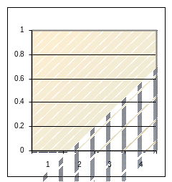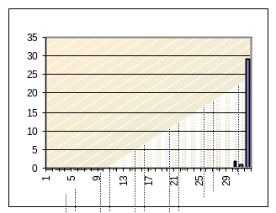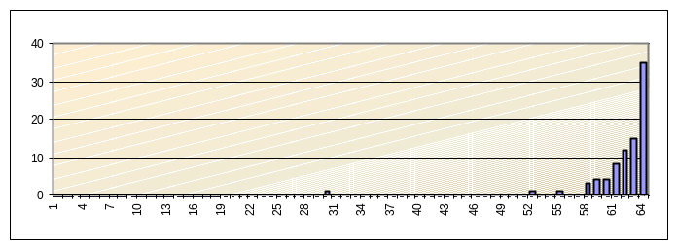
1.1. Little 1.2. Average 1.3. High
Each row in the graph shows us the amount of Threads stuck in an infinite loop. As concluded before, the earlier the bug occurs more Threads wind up in infinite loop. Thus, the graph shows up that most of the bugs appearances happened at the early stage.

2.2.3. Yield test
In this test we will introduce a basic yield noise to the program. The noise will be applied only to one parameter: first, which is an important variable used inside Enq() and Deq() before checking the state of the Buffer.
We will use single variable, yield, noise before and after, and 90% for the noise to happen, with 90% that the loop will happened. The test will run 100 times.
The amount of bug found at each level of concurrency:
- Little concurrency: 0/100
- Average concurrency: 35/100
- High concurrency: 76/100
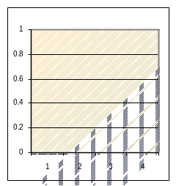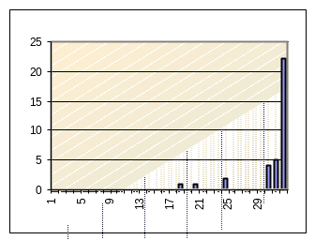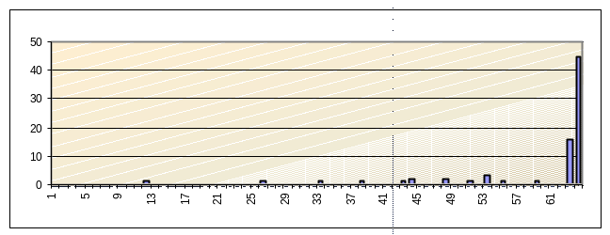
2.1. Little 2.2. Average 2.3. High

2.2.4. Barrier test
In this test we will introduce a basic barrier noise to the program. The noise will be applied only to one parameter: first, which is an important variable used inside Enq() and Deq() before checking the state of the Buffer.
We will use single variable, barrier noise before and after, and 90% for the barrier to happen, with 10ms delay. The test will run 100 times.
The amount of bug found at each level of concurrency:
- Little concurrency: 0/100
- Average concurrency: 30/100
- High concurrency: 85/100
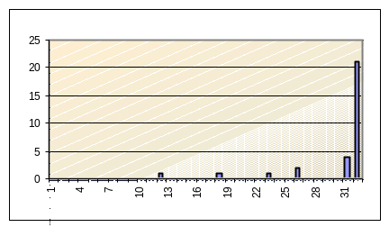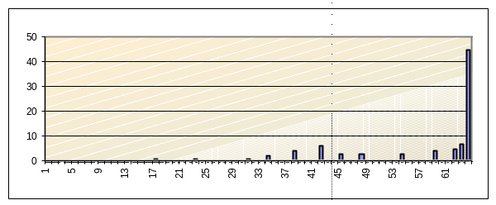
3.1. Little 3.2. Average 3.3. High

2.2.5. Multiple noise sources test
In this test we will use the barrier test on multiple parameters. We will chose a set of three parameters: ‘first’, ‘last’ and ‘active ‘.The last parameter is used in both methods (Enq() or Deq()) at the end of the method after the Thread access the Buffer.
We will use single variable, barrier noise before and after, and 90% for the barrier to happen, with 10ms delay. The test will run 100 times.
The amount of bug found at each level of concurrency:
- Little concurrency: 0/100
- Average concurrency: 35/100
- High concurrency: 89/100
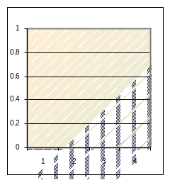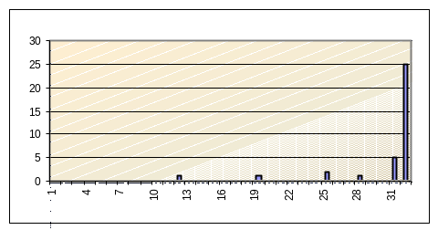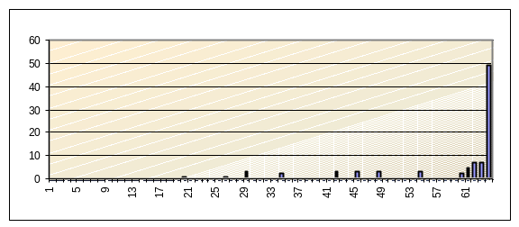
4.1. Little 4.2. Average 4.3. High

2.3. Results Analysis

2.3.1. Little Analysis
The results from the four tests haven’t resulted in a bug. So it’s obvious that RaceFinder didn’t help us finding the bug.

2.3.2. Average Analysis
The following graph shows the amount of tests, which the bug occurs in.
As seen, there is no big difference between the test, all four goes between the range of 30 to 35, while the basic (without noise) is 32.
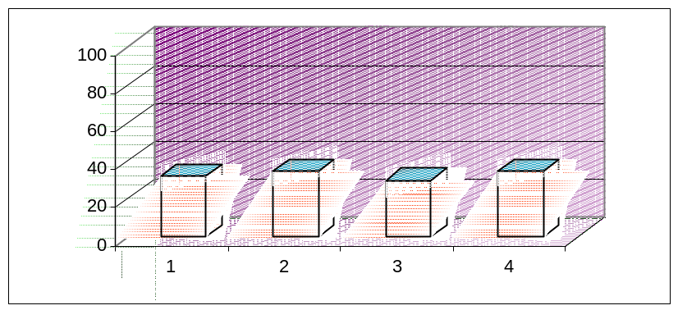

TESTS
1 – basic test
2 – yield test
3 – barrier test
4 – multi test
The following graph shows the results from the four tests using average concurrency. It shows that the distribution of the bug appearing is more or less identical, thus strengthening our assumption that RaceFinder won’t find the bug.
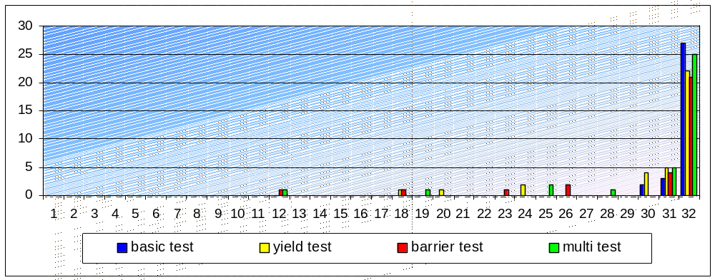

2.3.3. High Analysis
The following graph shows the amount of tests, which the bug occurs in.
As seen, there is no big difference between the test, all four goes between the range of 76 to 89, while the basic (without noise) is 84.

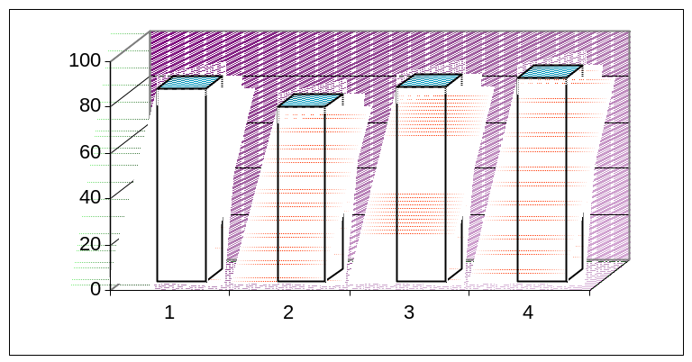

TESTS
1 – basic test
2 – yield test
3 – barrier test
4 – multi test
The following graph shows the results from the four tests using average concurrency. It shows that the distribution of the bug appearing is more or less identical, thus strengthening our assumption again that RaceFinder won’t find the bug.
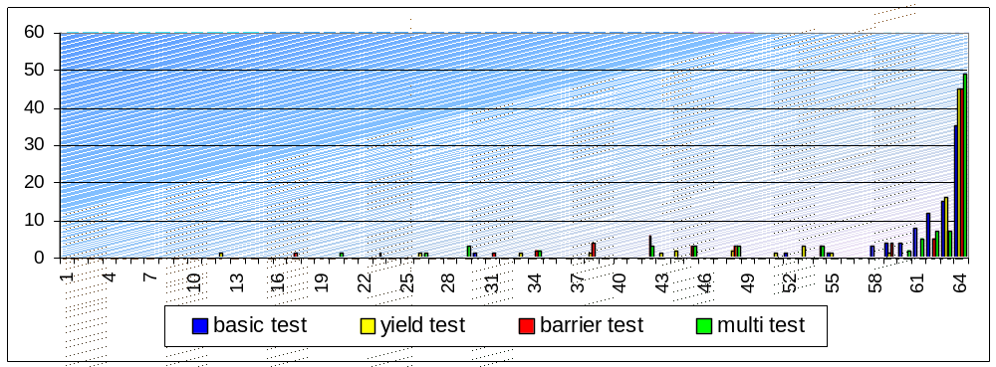

2.4. Conclusions
As expected we saw from the results that the number of times the bug occurs according to its concurrency parameter is the same more or less. The bug pattern at all the graphs stays the same: most of the bugs occur early at the running while the rest spread at most at the early stage and fewer at the late stage of the program running.
Thus, if we want to force the bug to happen we need to take a different approach.

3. Finding The Bug

3.1. Overview
As seen from the results analysis and the conclusion above, the noises made by the RaceFinder were useless. And so, we need some kind of logic to force the bug to appear.
We may be able to do so if we had the control over the Synchronizer, meaning if we had the ability to choose which Thread will run next and which Thread will be awaken from the suspension state after a different Thread had successfully accessed the Buffer.
Because such control is unavailable to the common user, who doesn’t have access to the wait() and Notify() code, the following algorithm will only work in theory.

3.2. Algorithm For Causing The Bug To Appear

3.2.1. Brief Description of The Algorithm
The following algorithm describes which kind of type (Producer or Consumer) will be able to access the Buffer. Between the two types, the algorithm separates between those in ready state and those in suspended state. Consequently, the algorithm doesn’t differ between two Instances of X type in Y state, each one may replace the other if it is able to.

3.2.2. The Algorithm
Assume, N is the Buffer size and Nt is the number of Producers / Consumers.

- Run N Instances of Producer, so that the Buffer will be full.
- Run all the Producers, so they all will end up at suspended state
- Run N Instances of Consumer, so that the Buffer will be empty.
As a result from this successful running, wake up N Instances of Producer.
- Run all the Consumers, so they all will end up at suspended state
- Run the N Instances of Producer, who got out of suspension. As a result from this successful running, wake up N other Instances of Producer.
- Run all the Producers, so they all will end up at suspended state

Now all the Instances are at suspended state, meaning all the Thread stuck on wait() command.
By applying the algorithm, we successfully force the bug to happen, and in its early stage meaning that all 2Nt Thread from 2Nt Threads created will wind up stuck in a deadlock.

3.2.3. A Note
Notice from line 5 of the algorithm, that when N Instances of Producer successfully access the Buffer, another N Instances of Producer must be available. Thus making an important requirement that the number of Instances from the two kinds, Nt, must be greater or equal to twice the size of the Buffer: 2N <= Nt.
If not, after N Instances of Producer finish their work, they will need to wake different N Instances.
If the number of available Producer Instances in suspended state is less then N (making Nt less then 2N) then one or more on the Consumer Instances will be waken by them, making it impossible to cause the bug in line 6, because after line 6 there will be one or more Consumer Instances in ready state. After one or more of them will run, the Buffer will no longer be full and if by chance the Consumer Instant wakes up a Producer Instant the program will go on.

3.2.4. Conclusion
From the last paragraph, we concluded that the number of Threads of one type (Producer or Consumer) must be equal or greater than twice the size of the Buffer in order for the bug to occur.
We may conclude than, that if 2N >= Nt the bug would not occur.
Moreover, assuming the Buffer size is a constant, as far as we increase the number of Threads, the change for it ti occur increases. That conclusion justifies the choice of increasing the number of Threads as we increase the level of concurrency, for little, average and high.

4. Summary

The results from using the RaceFinder had proven to be ineffective to help us finding the bug. This results where expected due to the nature of the bug.
Therefore we wrote an algorithm to help us find the bug at the program. The algorithm is only theoretical, because we can’t take control over the Synchronizer. If we could we would change the notify() code, so that we will be able to choose what kind of Instance we want to wake.

